“Program 1 - Animated and Remixed Blexbolex” by Zoë Wood is licensed under CC BY-NC-SA. Accessed from www.engage- csedu.org.

CPE 123: Introduction to Computing – Computational Art – Fall 2015
Program 1 – Animated and Remixed Blexbolex

Due date: Monday, 10/5 11:59pm Modality:
- This is a pair assignment. Working from your own processing sketch for Lab 2 (Blexbolex), you will be partnered with another student in order to combine your two sketches and create a unique animation. You may talk to other students and your instructor to see what they are creating and how they did it. As always, with the exception of your partner, you are not allowed to ‘cut and paste’ code from another student or a tutorial in order to complete this assignment, nor can any segment of your code (which generates a visual component) exactly match another student’s code for this assignment (with the exception of your partner).

Objectives:
- Practice using Processing
- Practice using simple primitives and shapes in Processing
- Practice using methods to encapsulate parts of your code for re-use
- Practice integrating two student’s code
- Practice scaling and translating shapes into a single coordinate frame
- Practice animating via transforms and variables
- Practice developing your aesthetic
- Make an interesting ‘story’ combining two existing designs and adding animation

Requirements:
For this assignment you must generate a combined scene from two different Blexbolex designs that incorporate animation of the main characters. Your final sketch must be either twice the width or height of the original two Blexbolex sketch reproductions.

Your final combined sketch must have all the original elements placed into a new unified sketch that are either side by side or one of top of the other (please select the option that makes the most sense).

Your final sketch must use methods and animation of the two main characters.

Step 1: Start by modifying your own individual Blexbolex sketch to use methods. Recall that you will need at least a setup and draw method. In addition, you will need a method to draw the element that will be animated. I also highly recommend including a method to draw any background elements in your sketch.
Step 2: Combine your sketch with your partners. Be sure to modify the size of your canvas to accommodate both sketch’s elements. Decide on their placement and offset one of the other’s background and main characters to have them appear side by side. See Figure 1 for an example.

Step 3: Add the necessary variables to make both main characters animate. At this time I only expect very simple animation. (ie translation via incrementing a variable).

You and your partner are required to handin a final image and your final sketch code. Be sure that your sketch code has your name and your partner’s name as a ‘comment’. You and your partner will also be demoing your solution in lecture or lab.

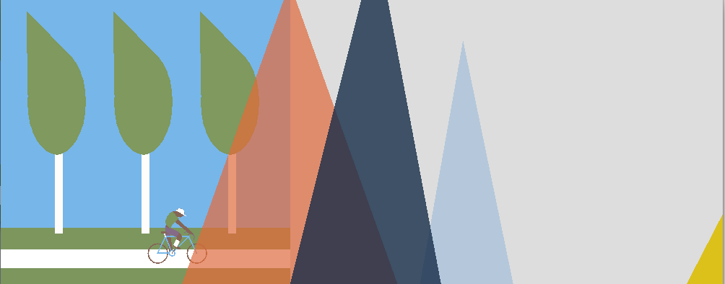
Figure 1: A frame near the start of the animation, showing the combined Blexbolex sketches (note the diver hasn’t entered the animation yet).
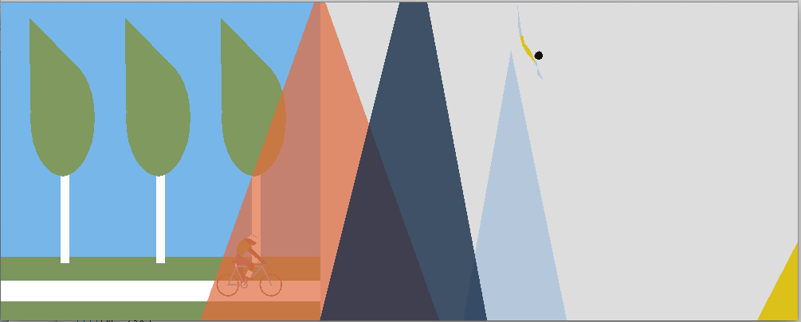
A later frame with the biker behind the mountains and the diver starting her dive.
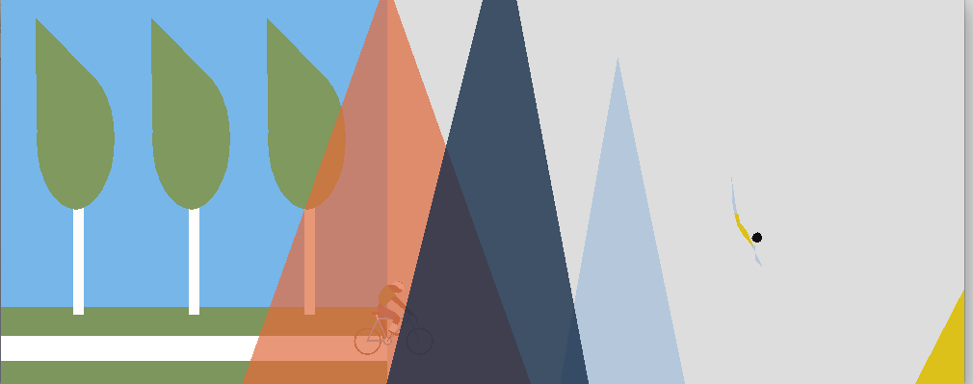
Another later frame showing both characters continuing their journeys.

Useful commands:
fill noFill stroke ellipse quad strokeJoin
strokeWeight translate rotate pushMatrix popMatrix

Here is a very simple example program using the necessary methods to animate very simply using transforms:
//a variable to control location int tx = 0;

//method to set up the sketch size void setup() {
size(400, 400);
smooth();
}

//method to draw my background
void drawSet(int offsetX, int offsetY) { fill(26, 29, 137);
rect(offsetX, offsetY, 100, 200);
fill(72, 75, 198);
rect(offsetX+100, offsetY+50, 100, 150);
}

//method to draw my character void drawChar(int tx, int ty) {
pushMatrix(); translate(tx, ty); fill(33, 137, 26);
ellipse(0, 0, 40, 40);
fill(110, 26, 137);
ellipse(-5, -5, 5, 5);
ellipse(5, -5, 5, 5); popMatrix();
}

//method to draw all elements of my sketch void draw() {
background(254); drawSet(100, 100);
drawChar(tx, 270); tx = tx + 1;
}

