. |  | .
. | Computational Art | Zo¨e Wood  .

1 Lab 6 - Implicit Lines and Circles

Goals

The goals for this lab are:

- Practice using a loop control structure to create an image made of
strokes based on implicit lines.
- Practice using implicit lines and implicit circles and the dis- tances from these equations to create a scene or object.

- Create new stroke styles using patterns of points, lines, and ellipses
that model the textures seen in many impressionist paintings.

Modality

Pair or Individual (per instructors specifications)

Overview

Impressionism:“Impressionist art is a style in which the artist captures the image of an object as someone would see it if they just caught a glimpse of it. They paint the pictures with a lot of color and most of their pictures are outdoor scenes. Their pictures are very bright and vibrant.”1
In particular, in this lab, we will focus on creating a scene that has very obviously textured strokes that just gives the observer the impression of a scene. We will be combining our knowledge of implicit equations to order space as either on one side or the other of lines and curves in order to model very simple scenes.
Sample impressionist paintings include:

1http://www.artmovements.co.uk/impressionism.htm

1

"Lab 6 - Implicit Lines and Circles" by Zoë Wood is licensed under CC BY-NC-SA. Accessed from https://www.engage-csedu.org.

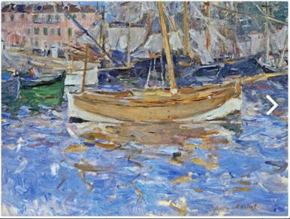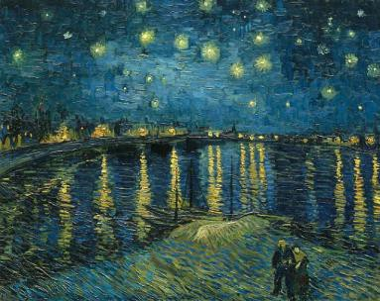

Figure 1: (left) Berthe Morisot ”Harbor at Nice” (right) Vincent Van Gogh: ”Starry Night Over the Rhone”

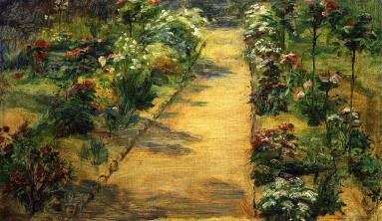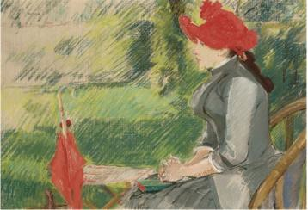

Figure 2: (left) Marie Bracquemond ”Landscape Garden Path” (right) Eva Gonzales: ”La lecture au jardin”

Details

This lab requires you to create an image using an implicit representation of geometry that is drawn using shapes to emulate paint strokes.
To complete this task we will use implicit functions, which can represent common geometric shapes like circles, lines and curves in two dimensions (and similarly planes and spheres in 3D). For every point in 2D space, for example, the implicit function for a circle will return a signed value propor- tional to the Euclidean distance of that point to the circle. The fact that the distance value is signed allows you to distinguish which points are on the interior of the circle and which are on the exterior. Specifically, for every sampled x, y point in space, by defining the center of a circle, (cx, cy) and radius r, the implicit equation for a circle is:

f (x, y) = (x − cx)2 + (y − cy)2 − r2

Using this equation and then looping over your entire screen (for a given sample rate), you can for example decide to draw points inside the circle one color and points outside the circle another color. For example, drawing an ellipse for every 10th pixel, blue on the outside, and black on the inside, you can create an sketch similar to the results shown in Figure 3. Similarly, you can create an image using an implicit equation for a line to create various images that color the image differently on two sides of a line, also shown

in Figure 3. The implicit equation for a line can be found in the resources section of this lab write up.

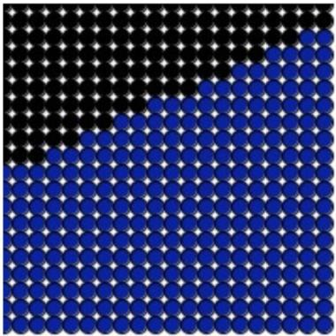

Figure 3: (left) Simple implicit circle sketch (right) Simple implicit line sketch

To make these sketches look more like a painting, you can vary the shape drawn and color slightly, using random or noise. Such as this variation on the circle and the line:

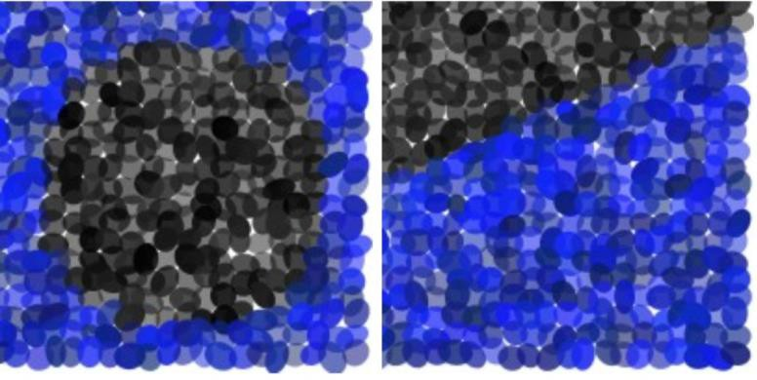

Figure 4: More painterly renderings of an implicit circle and implicit line by slightly varying the shape of each ’stroke’ (or draw primitive)

Task: You must create an image using Processing (or p5.js) which em- ulates paint strokes and uses a combination of both implicit circle(s) and implicit lines. For this sketch you must create a scene that models a com- posite scene using lines and circles (see Figure 1. For example you could create a simple scene with trees and the sun created using implicit lines and implicit circles as bounding lines for objects. We suggest you start with one shape at a time, for example try to just replicate the messy sun (shown in Figure 5).
To create your image you will use the magnitude of the implicit function (which is proportional to distance) to determine how far the stroke is from

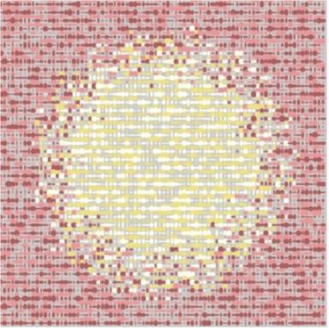

Figure 5: Painterly rendering of a sun using Processing and random to help make the strokes look different.

the original line and which side of the line/circle the equation falls. For example, you will use the sign (negative or positive) to determine which ’side’ the stroke falls on. In addition, you may use the magnitude of the distance to determine the intensity of the stroke color. For example, for a line or circle, using the distance to weight the color might look like one of the images shown in Figures 6. Be creative about alternating your stroke style and a random radius for each point.
Your lab must:

- be at least 400 x 400
- be in color
- create a scene or object using both implicit lines and implicit circles
- use the distance from the implicit line/circle to determine the color
- use points, lines, or ellipses to create the same scene with two different stroke types
- strokes should vary in color across the scene
- strokes should model the style of the textures found in impressionist art

The scene should be created using strokes that are similar to the textures found in impressionist paintings. The final scene should then be created with at least two different stroke types (i.e.: by varying the sizes of the strokes or how close together the strokes appear to each other).

Demo:

In order to receive credit for this lab, you must demo your sketch to your instructor or TA. For every lab, your score will be broken down 75% for

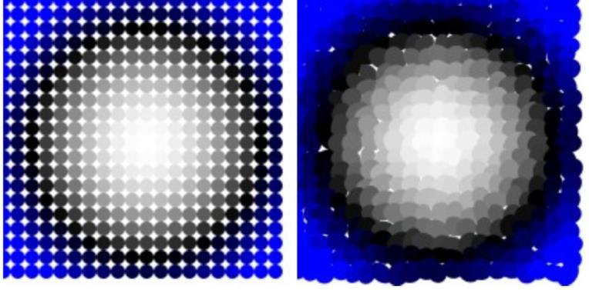

Figure 6: Using the distance to weight the color of strokes for an implicit circle.

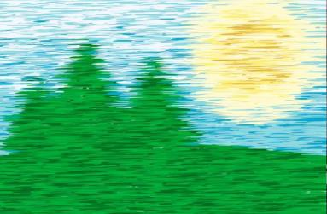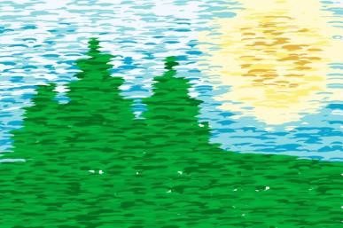

Figure 7: An example of using implicit circles for the ground plane and the sun and using implicit lines to find the intersection of three lines for each tree. The distance from the ground is used to determine the color of the sky and the distance from the center of the circle determines the color of the sun. Varying sizes of ellipses were used to create horizontal strokes and create different stroke types on the images.

meeting the technical requirements and 25% for aesthetics. Additional sample Impressionist paintings for inspiration:

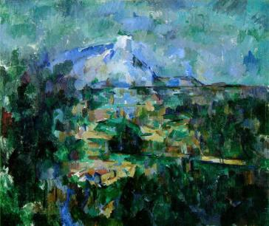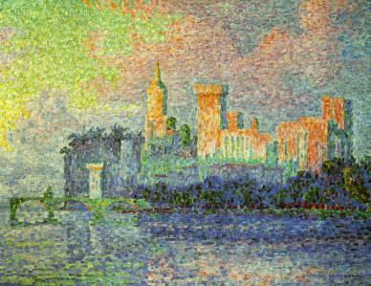

Figure 8: (left) Paul Czanne: Mount Sainte-Victoire view from Lauves” (right) Paul Signac: ”Le Palais des Papes, Avignon”

Resources:

Implicit Line - given two end points {x0, y0} and {x1, y1} the implicit line equation is:
f (x, y) = (y0 − y1) ∗x + (x1 − x0) ∗y + x0y1 − x1y0
Implicit circle - given a center {cx, cy} and radius r: f (x, y) = (x − cx)2 + (y − cy)2 − r2 = 0

/* Fall 2015 - example implicit circle sketch - ZJ Wood */ void setup() {
size(400, 400);
}

/* example method to evaluate the implicit equation for a circle */ float impl_circ(float cx, float cy, float radi, float in_x, float in_y) {
return ( (in_x-cx)*(in_x-cx) + (in_y-cy)*(in_y-cy) - radi*radi);
}

void draw() { background(255); noStroke();
for (int y=0; y < height; y+= 5) { for (int x=0; x < width; x+=5) {
if (impl_circ(width/2.0, height/2.0, 100, x, y) < 0.0) { fill(128, 128);
} else {
fill(12, 34, 56, 128);
}
ellipse(x, y, 5, 5);
}
}
}

