“Lab 3 - Introduction to conditionals using Surrealism (Art of Surprise)” by Zoë Wood is licensed under CC BY-NC-SA. Accessed from www.engage-csedu.org.

. |  |  | .
Fall 2015  . | CPE 123: | Computational Art | Zo¨e Wood  .

Lab 3 - surrealism: art of surprise

Goals

The goals for this lab are:

  - Practice writing an interactive Processing program
  - Practice using conditionals in your program
  - Practice testing where the mouse is clicked within an area of your scene
  - Practice using variables to control appearance
  - Make an interactive program that visually changes when a mouse is clicked in a certain area
  - Learn about surrealism

Modality

This is an individual assignment.

Overview

Surrealism: “A literary and art movement, dedicated to expressing the imagination as revealed in dreams, free of the conscious control of reason and convention. Surrealism inherited its anti-rationalist sensibility from Dada, but was lighter in spirit than that movement. Like Dada, it was shaped by emerging theories on our perception of reality, the most obvious influence being Freuds model of the subconscious.”
For our work, we will focus on the use of juxtaposition in surrealism. In particular the juxtaposition of dream and reality. As the founder of the surrealist movement, Andre Brenton said, the movements goal was to resolve

1

the previously contradictory conditions of dream and reality into an absolute reality, a super-reality.1. In this vein, you must design a sketch that includes two components that might not normally go together. Consider ‘The Son of Man’ by Magritte (see figure 1). Magritte said “Everything we see hides another thing. We always want to see what is hidden by what we see. There is an interest in that which is hidden and which the visible does not show us. This interest can take the form of a quite intense feeling, a sort of conflict, one might say, between the visible that is hidden and the visible that is present.
Please refer to the pinterest board ‘Comp Art - Lab 3 surrealism’ for examples of these types of juxtaposed images. Be sure to pin any to your own own board that you use as inspiration. You must have at least one source image used to inspire this assignment.

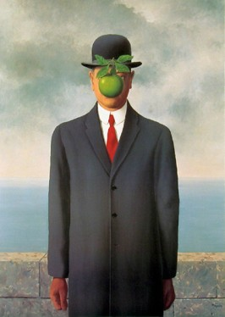

Figure 1: A classic example of a surrealist scene. Rene Magritte’s ‘Son of Man’, 1964

Details

Tasks: For this lab, you must write your own interactive Processing pro- gram which is a surrealist scene with two juxtaposed components (the two different components must be easily distinguished - i.e. the apple and the man in Magritte’s ‘Son of Man’).
Your scene must include some surrealist juxtaposition (ie justapose two things that create a sense of surprise based on their presence in the same frame). Your sketch can surprise the user by having a strange juxtapostion appear after a mouse click (ie see Figure 2 where the owl’s face turns into a human face) - or the scene can start strange (ie imagine the owl starting with

1http://www.artmovements.co.uk/surrealism.htm

the human face) and the mouse click changes the scene. Some possibilities include moving the front object away to reveal something strange, having something strange animate when the user clicks, etc.
The visual change to your sketch must happen when the user clicks on one visually defined portion of the scene. For example in Figure 2, the owl’s face only changes if the user clicks on the owl’s face. You must control this via using conditionals and variables to control what is drawn.
Your ‘sketch’ of the scene must:

- Include juxtapostion to create a surrealist scene (your scene must be composed of complex shapes, created with Processing that can then be animated). These shapes must be coherently organized into a recogniz- able whole (ie ’an owl’, ’an apple’, and must be significantly complex,
i.e. include at least 4 composed shapes or a shape with 15 or more vertices)
- Use conditionals to only respond to a users click within a small region (must be clear what the region is)
- Trigger a change is the visual appearance of the scene (something could animate or change)
- The visual change must be controlled with variables
- The interaction should be controlled via the mousePressed, mouseDrag or mouseMove functions

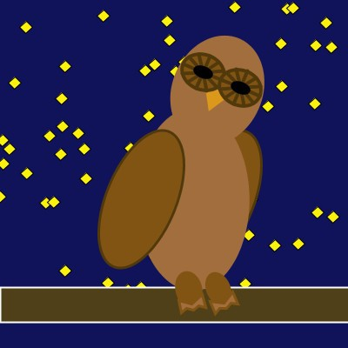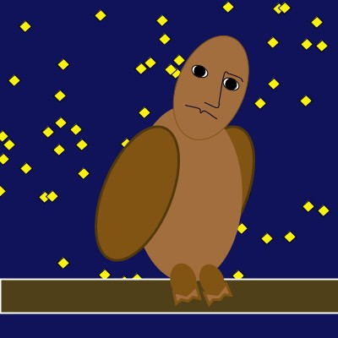

Figure 2: An example of two frames of my surreal scene. On the right is how the sketch starts. When the user clicks in the region of the owl’s face, the sketch changes to draw a human face.

Demo:

In order to receive credit for this lab, you must demo your sketch to your instructor. As always, 75% of your lab credit is due to technically meeting

these specifications, 25% of your grade is based on aethetic effort (ie did you make a compelling surreal scene).

Resources

some useful commands:

mouseX mouseY mousePressed mouseDrag mouseMove
if/else statments

//simple program to demonstrate mouse click and conditional logic - Z. Wood boolean animate;
int ty = 0;

void setup() { size(400, 400);
animate = false;
}

void mousePressed() {

if (mouseX > 300 && mouseY > 300) { animate = true;
}
}

void draw() {

background(46, 130, 229);
//draw the character (a ball) fill(4, 35, 72);
ellipse(200, ty, 60, 60);
//draw the region to click mouse fill(128);
stroke(255); strokeWeight(2); rect(300, 300, 99, 99);

//only if the user has clicked on the box should the ball drop if (animate) {
ty += 1;
}
}

