Intro to Computer Science
PA02

Working with Selection Statements

Code due by Wednesday, February 5th at 11:00 AM
Paperwork due the same day at the start of class

Introduction
This week we have been working with selection statements. Let's see if you understand this idea.
Just like last week, in this assignment I would like you to :
- Look at the two customer requests below (step #1 in the software development process).
- For each request I would like you to analyze and design a solution to the problem and write a one paragraph summary of what process you need to use to solve each of the problems below). Use this process to place comments in your code file before you begin programming! I will be collecting these paragraphs as part of a "design document" that you will hand in to me in class.
- After you have studied the problems and prepared your problem solving solution you should write the code that solves each of the problems. Please make sure that you write the code in two separate files saved with the names given below.
- Once you think you have the code working, TEST it thoroughly.

Notes and requirements:
- Make sure that you save your programs in the correctly named files
- The top of each file should contain a header very similar to the one we have used the last few weeks
- Use meaningful variable name with the proper style (useCamelCase)
- Use meaningful constants and names where appropriate and use proper style

Customer Request #1 (weight.py)
You are contacted by Dr. Zoltan Pepper who is analyzing the overall fitness of olympic athletes. To help understand how they compare he has decided to use the concept of Body Mass Index (BMI).
BMI is a number calculated from a person's weight and height. It does not measure body fat directly, but research has shown that it correlates well with body fat calculations from more dependable measures such as underwater weighing. The formula for BMI is:
BMI = weight / height²
where weight is in kilograms and height is in meters.
For example, Peter Kirkbride (a weightlifter from the UK) is 74.5 inches tall and weighs 207 lbs. This means his BMI is 26.2213925..
[Note, 1 inch is 2.54 centimeters. 1 pound is 0.453592 kg]
Dr. Pepper also points out the following table from the CDC
BMI | Weight Status
Below 18.5 | Underweight
Below 25 (but 18.5 or higher) | Normal
Below 30 (but 25 or higher | Overweight
30.0 and above | Obese

Dr. Pepper asks you to write a program that:
- asks for the users weight in pounds and height in inches (note: you must prompt for weight first, height second to get the maximum amount of points)
- converts both of these to kilograms and meters
- calculates the BMI
- prints a message to the user containing BOTH their BMI number and their weight status based on the table above

Customer Request #2 (calculator.py)
Esther Mate's least favorite subject at school has always been mathematics. She is always searching for the simplest calculator instructing her through every step of the way and helping her with errors.
Esther asks you to write a script (called calculator.py) that:
- takes in two integers that are both between 0 and 100.
- takes in an operator to operate on the integers.
- prints the first error encountered then does not continue execution.
- Errors include:
  - either of the integer values is not between 0 and 100.
  - the operator is not of the type: +, -, *, /, //, %, **
- prints the correct calculation if the two integers and the operator are all valid.
For example
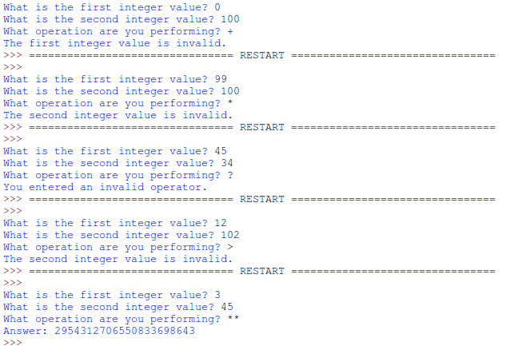
**NOTE: Be sure your program's output matches the above screenshot (the errors triggered and the order of questions asked) to receive the most points.**

Final Submission
To upload your homework for grading, log on to eLearning, select this class, and navigate to the "Assignment Submissions" area. Click on the "Programming Assignment 2" folder and upload both python files in their designated locations.
In addition to this, you should print paper copies of your code and design document. Please submit these stapled printouts in the following order in class the day the assignment is due:
- design document
- weight.py
- calculator.py

