PA07
"Oneyay allsmay epstay orfay anmay."
Objective: Get more practice with strings, looping, and writing functions

Code due by Monday, March 31st, 11:00 AM
Paperwork due the same day at the start of class

Remember, before you begin this project, review the new design document and function commenting styles that I expect. Please create the design documents and function comments before beginning the actual coding.

An introduction
You are contacted by Mr. I. Hoggs, president of the IPLS (International Pig Latin Society). He admits that despite being president of the society, he has always had some difficulty converting from English to Pig Latin. He asks if you could help him by writing a program to convert words/sentences from English to traditional "Pig Latin."

Pig Latin?
Some of you may have played with Pig Latin as a kid. There are many slightly different rule sets for Pig Latin. The version we will use is:
- RULE 1 - If the word begins with a consonant - such as "hello" or "this" - divide the word at the first vowel, swapping the front and back parts of the word and append "ay" to the word. The previous 2 examples would produce "ellohay" and "isthay".
- RULE 2 - If the word begins with a vowel - such as "am", "are" or "i" - append "way" to the word. The previous examples would produce "amway", "areway" and "iway".
- RULE 3 - If the word has no vowels - such as "my" or "thy" - leave them alone. The examples would produce "my" and "thy".

The Final Project
Eventually I want you to have code that will take an entire text file and convert it to Pig Latin. For this assignment I am going to cut out the file manipulation - we will save that for later. Instead, take in a single sentence (with no punctuation except the ending period) and translate that sentence into pig latin.
Let's think about this problem from the top down. Our full blown project should:
- Read a single "sentence" from the user.
- Break the sentence into individual words
- For each word, convert it into PigLatin...
- by finding the first vowel (if it exists)
- And finally, print out these converted words in normal sentence format
As I look at this project, we want to do this in several manageable steps (incremental development), and in fact, we don't start with step one.

Part A - (Step 4) Finding the first vowel
Begin by writing a function (in a file called pa07.py) called findFirstVowel(). This function should
- Take in a single parameter which is assumed to be a single word
- Search that word for the index location of the first vowel ('a', 'e', 'i', 'o', 'u').
- It then returns the index value of that first vowel, or a negative 1 when there is no vowel.
- Make sure that this function works regardless of the case of the letters submitted
For example,
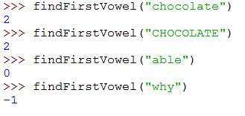

Part B - (Step 3) Translating one word
Now, write another function called translateWord() that:
- Takes in a single parameter which is assumed to be a single word
- Sends that word to findFirstVowel() (from Part A) and grabs the result sent back
- It uses the result of part A to see which of the three rules apply (see above)
- It uses this information to modify the word appropriately, and returns the String representing the translated word.
For example,
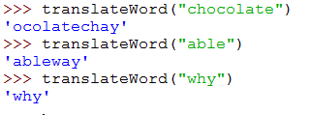

Part C - (Step 1, 2, and 5) Starting to translate one sentence
This turns out to have several pieces to it, so let's break it down into sub steps
Now add a function to your code called pigLatinTranslator(). This function should:
- Accept a single parameter, assumed to be one sentence.
  - You may assume there are no punctuation marks IN it (no commas, no hyphens, etc.).
  - You should assume that there is a period at the end of the sentence
- Removes the period from the sentence and changes all to lowercase letters
- Breaks the sentence into individual words using split().
- Uses the translateWord() function from part B to translate each word, printing each word as it goes along
For example,
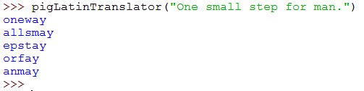

Part D - (Step 5) Reassembling the translated sentence
Now modify pigLatinTranslator from Part C to:
- Assemble a single string that is the translation.
- Capitalize the first letter.
- Put the period back on the end.
- RETURNS the final output string
For example,
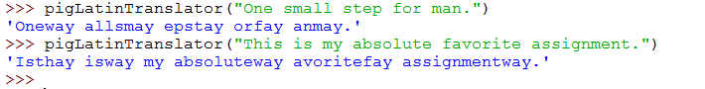

Final Submission
To upload your homework for grading, log on to eLearning, select this class, and navigate to the "Assignment Submissions" area. Click on the "Programming Assignment 7" folder and upload the python file in its designated location.
In addition to this, you should print paper copies of your code and design document. Please submit these stapled printouts in the following order in class the day the assignment is due:
- design document
- pa07.py

