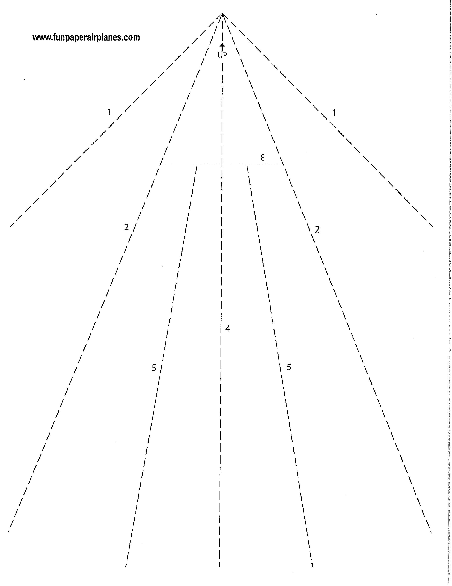

- Write down 3 things about yourself that others might not know (and you are willing to share)
- DO NOT put your name on the paper
- Make an airplane
- Await further instructions

